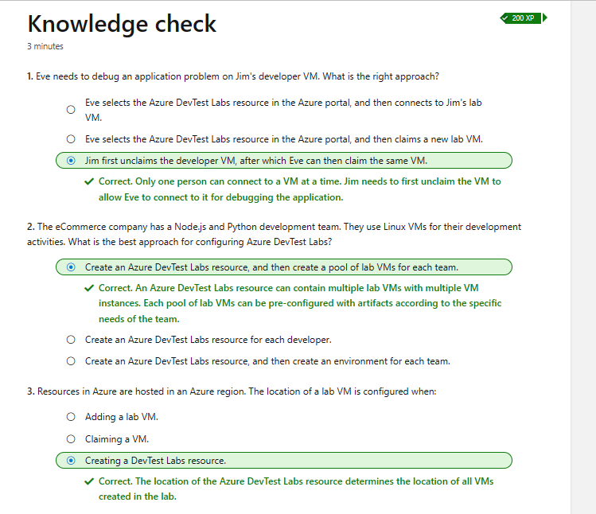

This is the final step of the lab where I entered the suggested command and it was successful.

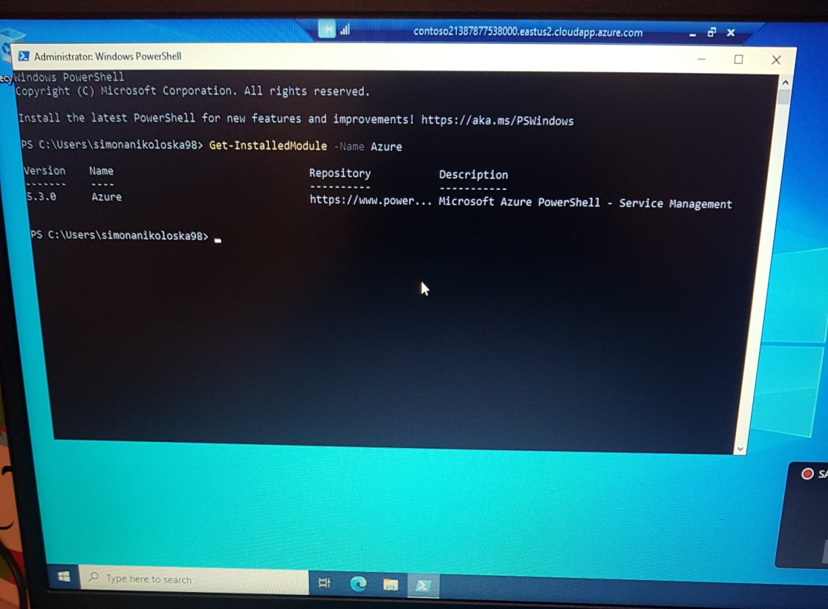

For the previous steps I have activated Sandbox and I have used Azure Pass for Subscription.